Q1 a)
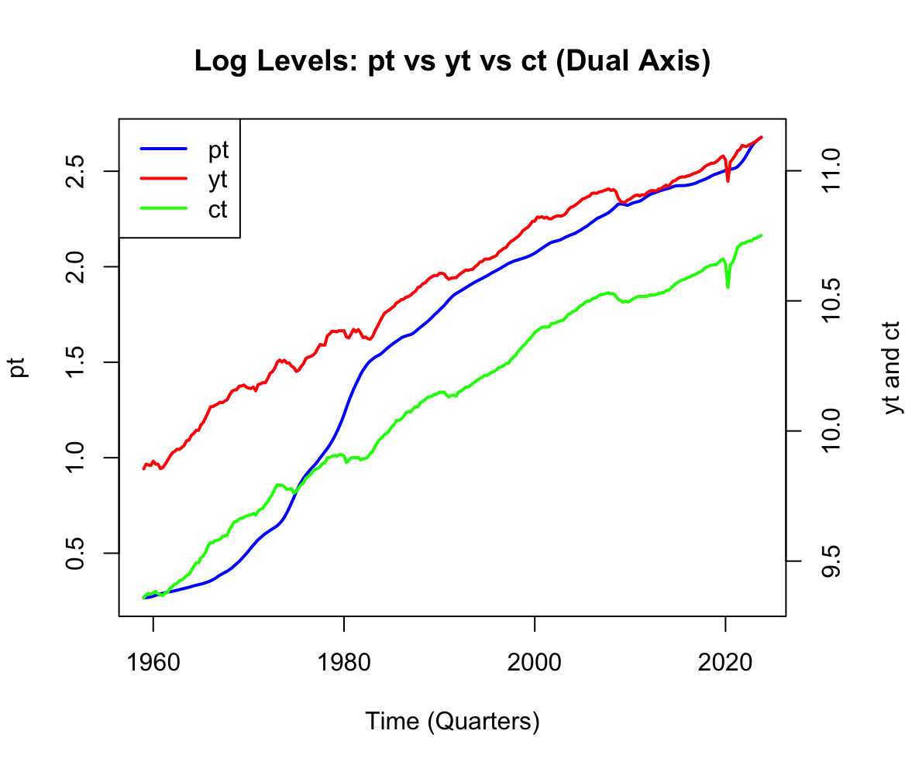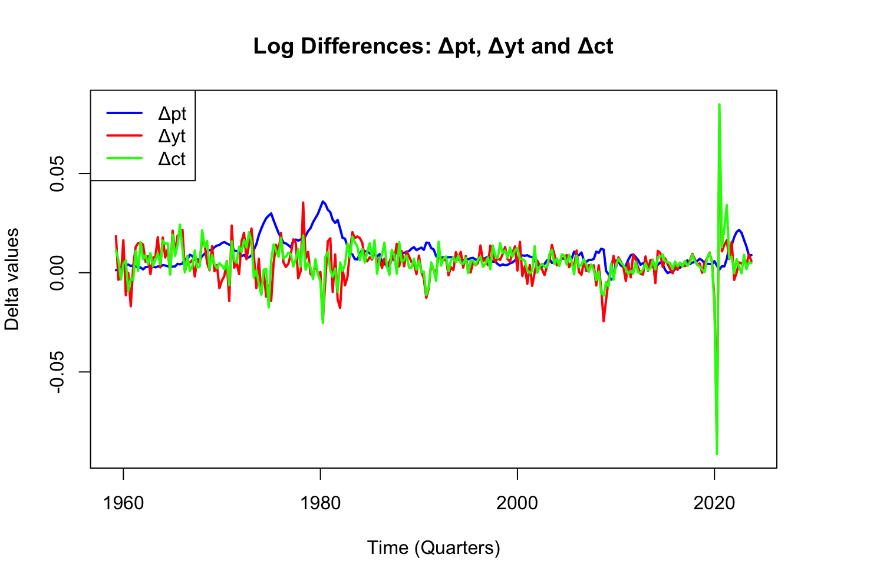
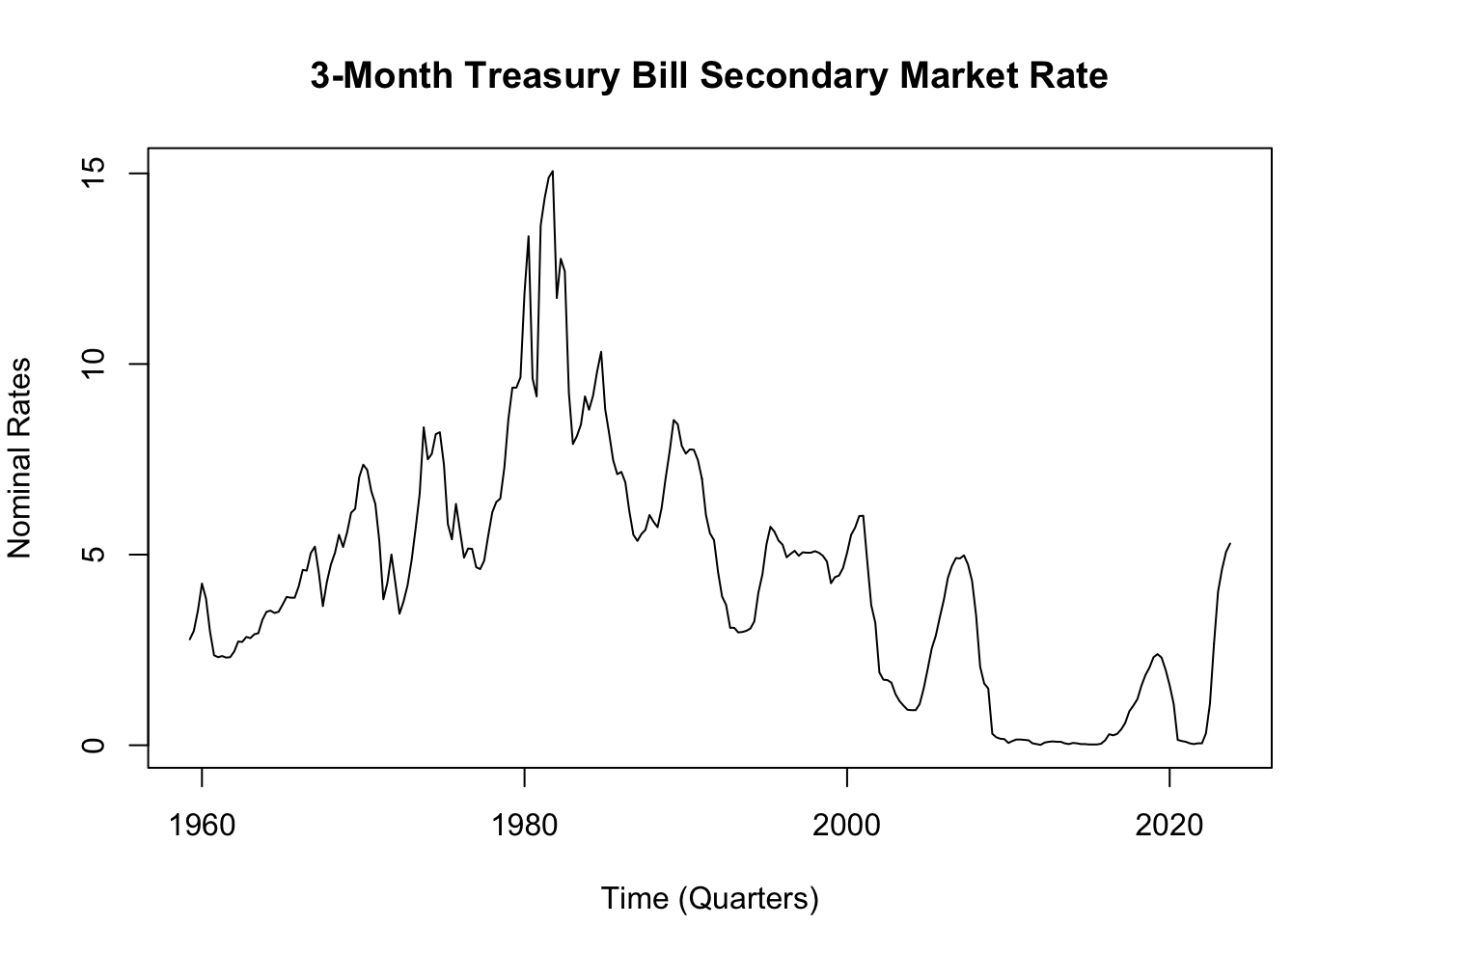
Quarterly time-series of macroeconomic indicators in the USA for the period 1959Q1-2023Q4 (260 observations, where pt is CPI, yt is real GDP, ct is real PCE)
From the log levels of inflation and gdp time series, it is observed that all appear to have a strong upwards trend suggesting non-stationary processes for the means are not constant over time as shown between 1959 to 2020.
The first differences depict fluctuations around a constant mean and has maintained constant variance with exceptions to a volatility spike in 2020. Overall, this implies a difference stationary characteristic which is consistent with I(1) processes meaning that the trend is most likely stochastic for pt, ct and yt.
Nominal interest rate depicts no simple deterministic for the market rate increases from 1960s to 1980, dropping down close to 0% during the 2000s before rising sharply past 2020. This prolonged period of highs and lows suggests that shocks accumulate while the mean appears to change overtime particularly during different economic periods (high interest rates in the 1980s and near-zero rates post-2008). Overall, the interests rate process appears to be a stochastic process and shows signs of strong autocorrelation.

b)
i. $y_{t}=9.945+0.004757t+ϵ_{t}$
$$ct=9.429+0.005305t+ϵ_{t}$$
$$pt=0.271+0.0101t+ϵ_{t}$$
ii. $μ$: $∆pt= 0.009310287, ∆yt=0.004918979, ∆ct=0.005378509$
iii. The purpose of these estimations is to characterise the underlying growth behaviour of the series and assess the presence of a trend. The estimates of the mean difference $\hat{μ}$ and the time trend coefficient $\hat{δ}$ yielded very similar results: $y_{t}$0.475% vs 0.490%, $p_{t}$1.01% vs 0.931%, and $c_{t}$0.530% vs 0.537%.
Intuitively, both measures capture the average growth rate in the log-level series. The time trend coefficient reflects how the mean evolves over time, while the mean of the first differences captures the average change in the series. The similarity between these estimates suggests that both approaches are capturing a consistent growth pattern in the data.
Overall, the evidence is consistent with the log-level variables being non-stationary and the first-differenced variables being stationary. However, this comparison alone cannot fully establish whether the trend is stochastic, as this would require formal unit root testing. Is there something missing? Maybe this suggests that the variables are able to be forecasted
Q2 the Arima models were found to be inadequate and so despite BIC punishments, the models were all expanded leaning more towards AIC results. The three most adequate being 2,4,6 (AIC left, BIC right, Inflation model on top and interest on the bottom). What and where do we put the interest rates? Is it supposed to be talked about?
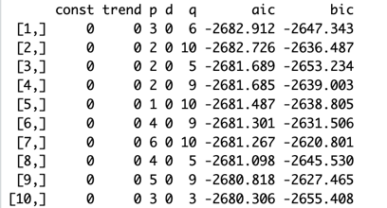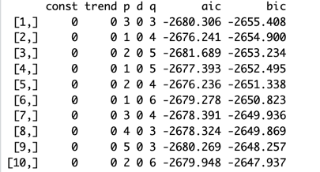
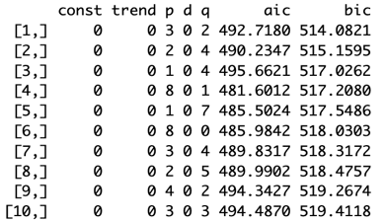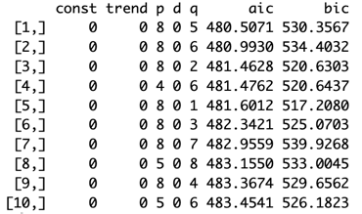
a)
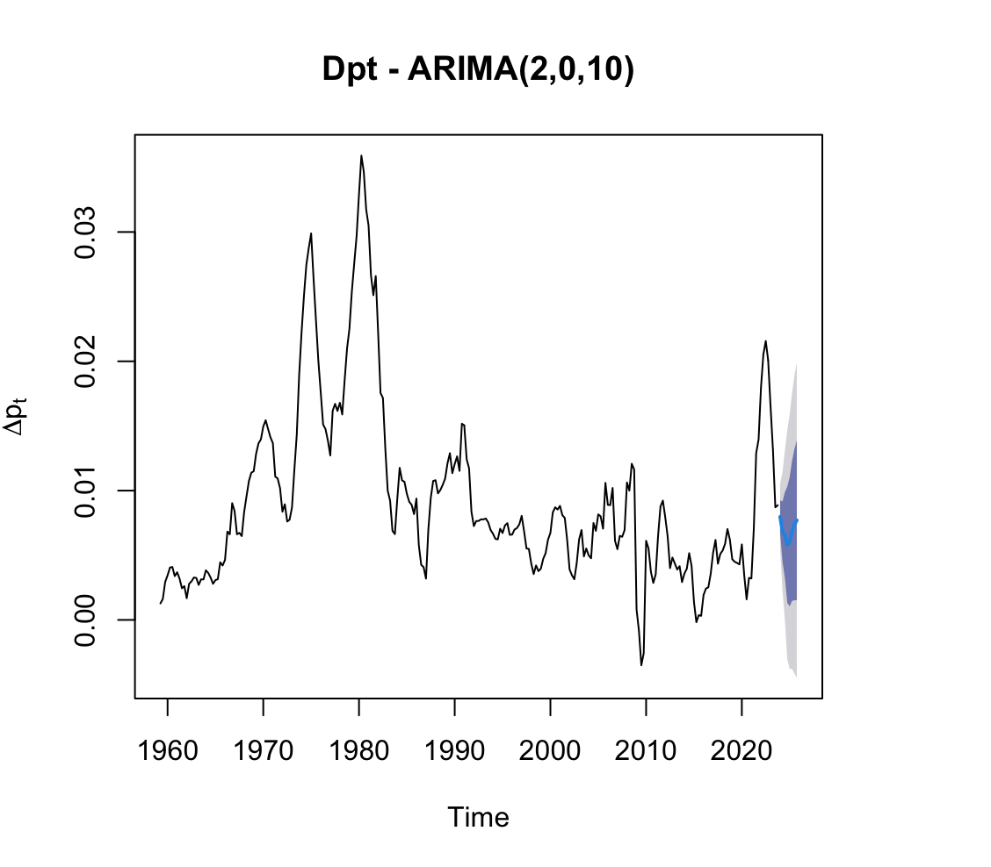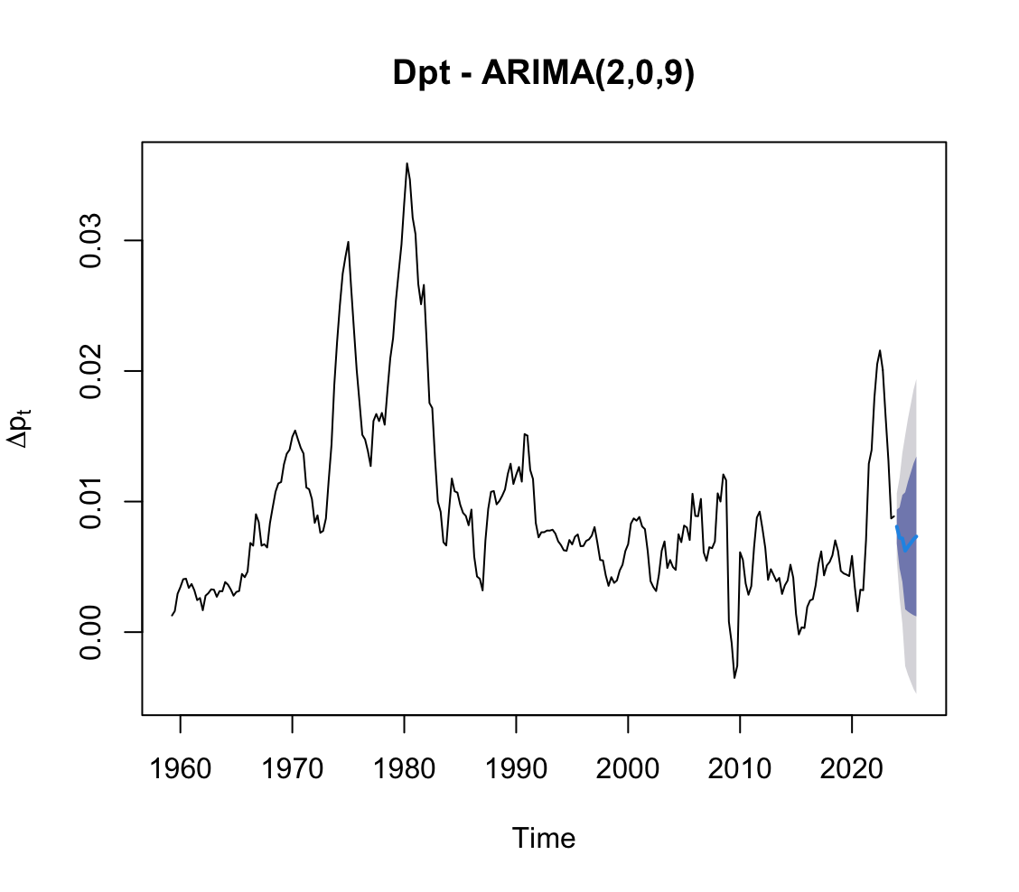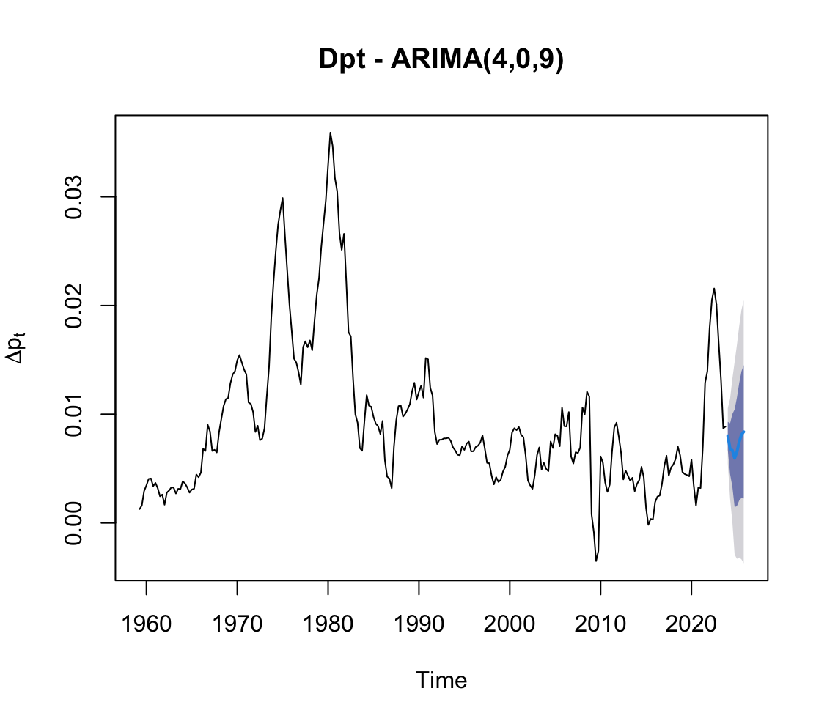
b) ARIMA forecasts are useful for policy makers as they provide a guidance of potential future economic conditions to make informed decisions on interest rate, fiscal policy, and forward guidance given historical data.
There are a few uncertainties to modelling with ARIMA, the first being that the model is based upon estimations of coefficients rather than known with realised data. All three models, (ARIMA (2,0,10) p=0.05, ARIMA (2,0,9) p=0.08 and ARIMA (4,0,9) p= 0.116) show similar forecasts which makes it difficult to determine the true underlying process. ARIMA models do not weigh in the potential of future shocks meaning that realised outcomes may deviate from the forecasts. This ties into the fact that the model assumes constant variance, whereas macroeconomic data often exhibits time-varying volatility. Overall, these uncertainties are reflected in the predictive intervals as the bands (68% and 95%) increases overtime and will be important for model selection. A d=0 means that the difference is stationary, does that mean we have a stochastic trend for pt? should we comment on ACF and the ljun box?
Q3
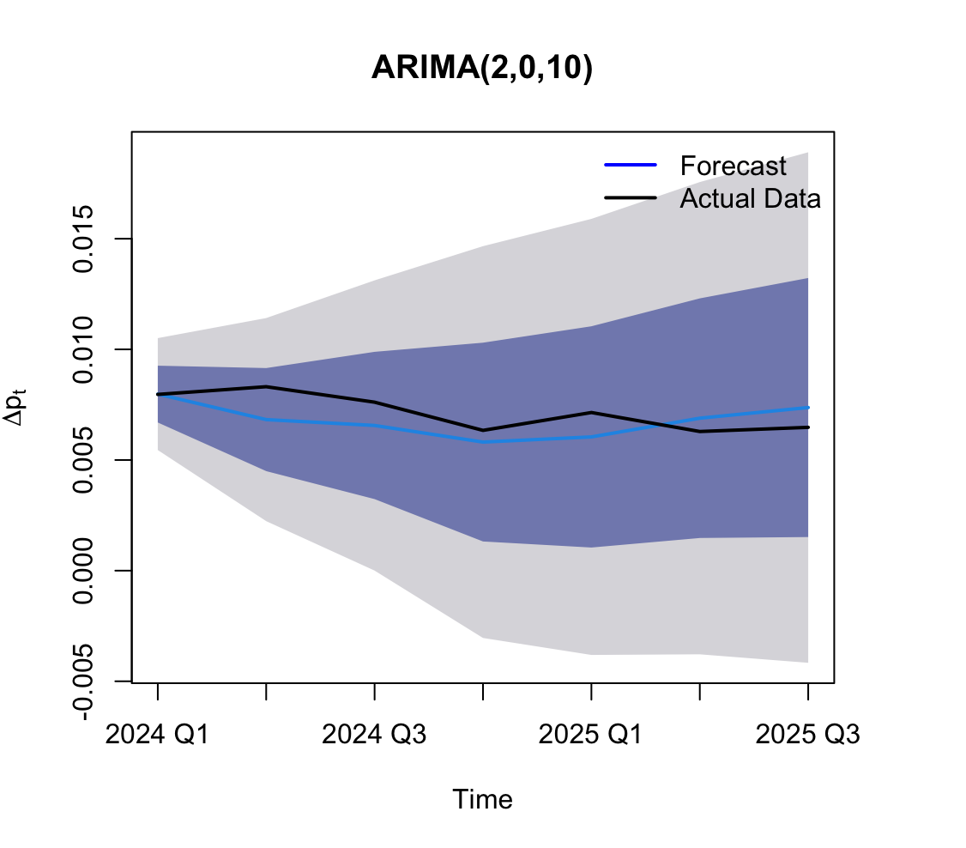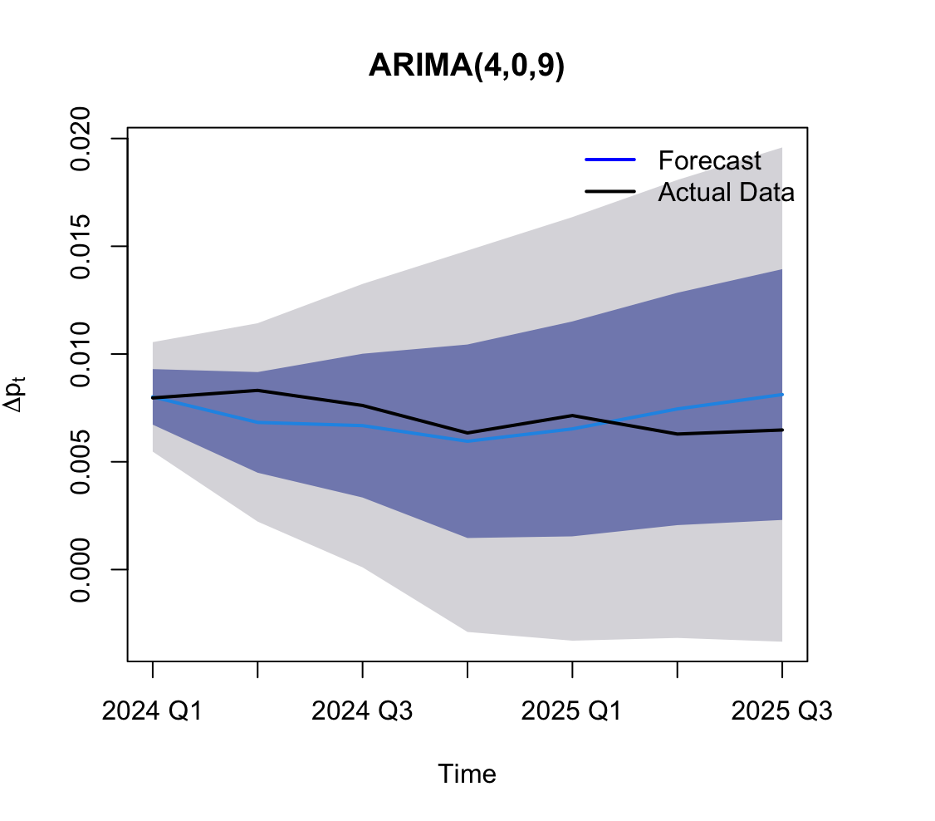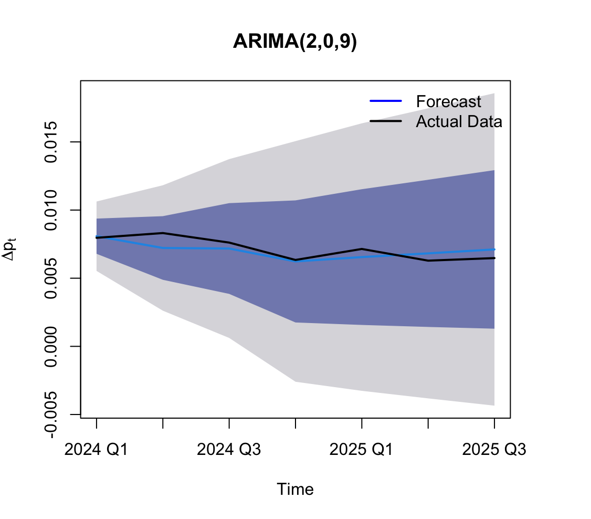
ARIMA (2,0,9) appear to have the least amount of forecasting errors as it closely matches the inflationary levels without overfitting to noise. The series has been relatively stable over the forecast horizon period and is reflected by the predictive intervals which does not appear to shift in a particular direction.
In contrast, ARIMA (4,0,9) and ARIMA (2,0,10) appear to have more variable forecasting where results attempt to capture short-term fluctuation rather than the underlying dynamics. Both models appear to suggest a stronger recovery in the rate of increase post 2024 Q4, causing a slight deviation to the actual inflationary levels.
However, the bigger picture suggests that all three models produce similar forecasts in that it puts more emphasis on predicting a steady increase in inflation. Finally, given residual testings and forecast results, a more parsimonious model provided superior performances.
Would this be the right take, or do we want something that has a direction since inflation can be subjected to shocks etc
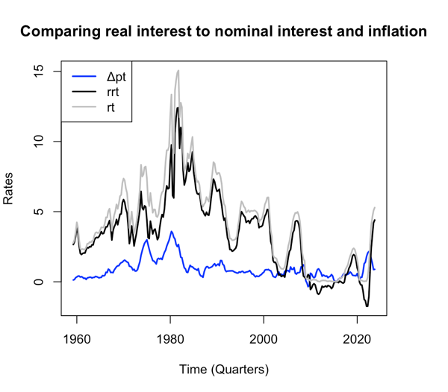
Q4
a)

The figure depicts inflation to be the most stable, averaging between 1-3% across the time series. Following this is the real interest rate (spiking up to 12%) which is expected for it excludes the effects of inflation from nominal interest (which spiked to 15%). Overall, real interest rate is slightly more stable than nominal, however, it is still very volatile, and all models are stationary given prior modelling with ARIMA that produced d=0 for inflation and interest. This talk of stationarity is important in my opinion to show that there is enough evidence to be able to comment on stability. Can you induce that rrt is also stationary cause of that
b)
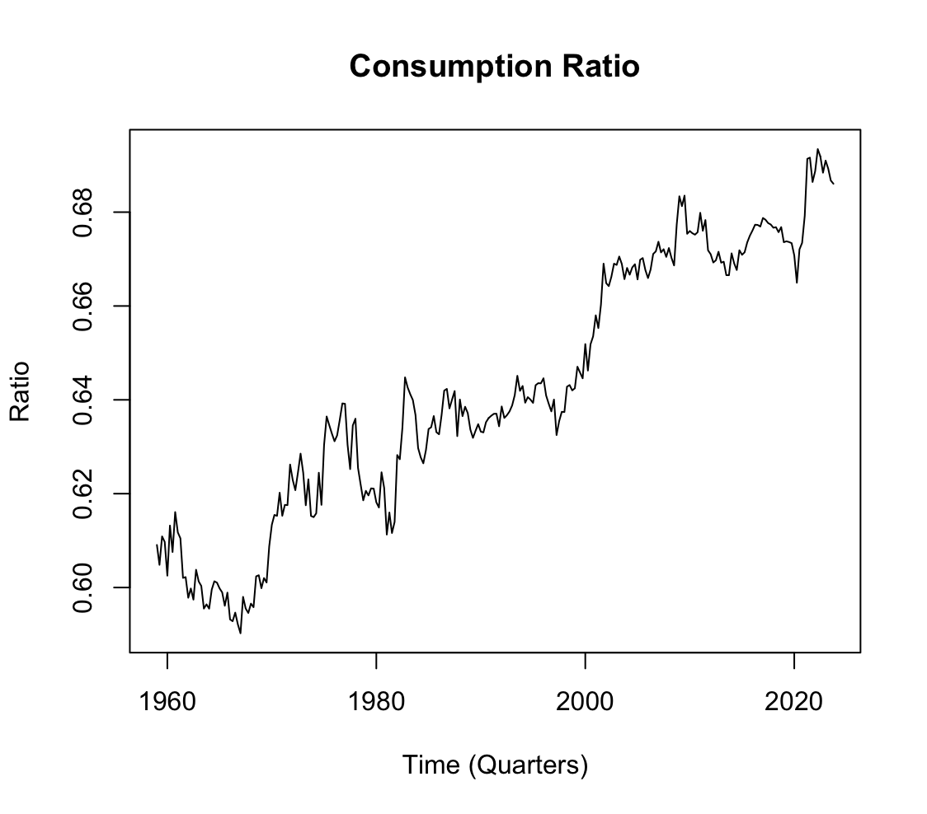
From the 1970s, the consumption ratio appears to have a strong upwards trend with only minor fluctuations. In an economic perspective, shows that consumption has been growing more than output over the same period. This leads to an increased share of GDP to being allocated to consumption. This may be driven by structural factors such as persistent trade deficits. Rather than indicating a deterministic trend, this pattern is rather more consistent with an economic structural change, or a very persistent stochastic behaviour.
c)BIC rankings on the left, AIC on the right
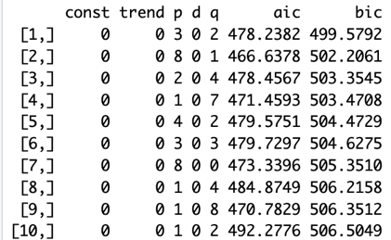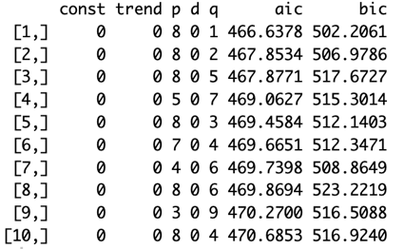
ARIMA(3,0,2) was tested to be inadequate (p<0.05) and so ARIMA (8,0,1) (p=0.307) was deemed the best model despite punishments of information criterion. A dominant feature is that d=0 which suggests that rrt is stationary and does not require differencing. A six autoregressive lag and a five moving average lag indicate the model relies more on past values and shocks to fit the model. However, it is still ranked second best in terms of BIC.

d) BIC rankings on the left, AIC on the right
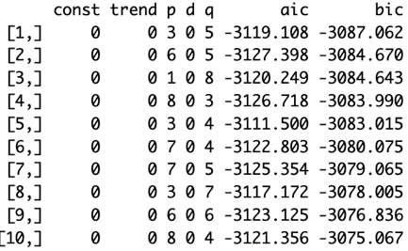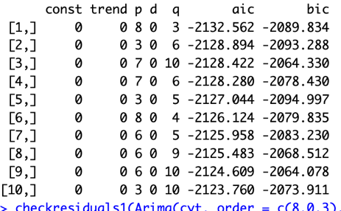
ARIMA (3,0,5) was tested to be inadequate (p<0.05) and so ARIMA(8,0,3) (p=0.153) was deemed the best model despite punishments of information criterion. A dominant feature is that d=0 which suggests that cyt is stationary and does not require differencing. This is consistent with observations in 4b, meaning that the apparent trend may be cause by persistent slow-moving fluctuations or structural changes rather than a true deterministic trend. A six autoregressive lag and a five moving average lag indicate the model relies more on past values and shocks to fit the model. However, it is still ranked second best in terms of BIC.
e)
The ARIMA model is useful for policy makers as it allows for predictions and forecasts given past data. The stationary nature of both series (d=0) meant that central banks, policy makers, have a critical indicator of the economic climate, and assess the impact of their policy moves on economic activities based on a benchmark path.
Similarly, cyt model allow policymakers to estimate consumer aggregate demand relative to GDP which is vital for assessing economic resilience during downturns and directing fiscal policies. MISSED CODE, it suppose to be the normal, I used the logged by accident
Q5.
- $σ_{CNY}^{2}=0.3368546 σ_{USD}^{2}=0.4380863σ_{TWI}^{2}=0.2674710σ_{SDR}^{2}=0.4491718$
The unconditional variances show TWI with lowest value of 0.267 suggesting that it is the least volatile out of the 2nd order series. CNY with 0.337 appears to be intermediate while USD and SDR have the highest, subsequently reflecting its volatility. These estimates are informative about overall dispersion of each stochastic process, however, this does not imply that returns are independently and identically distributed with constant variance. As a result, the results do not largely summarise the volatility of the processes.

b)
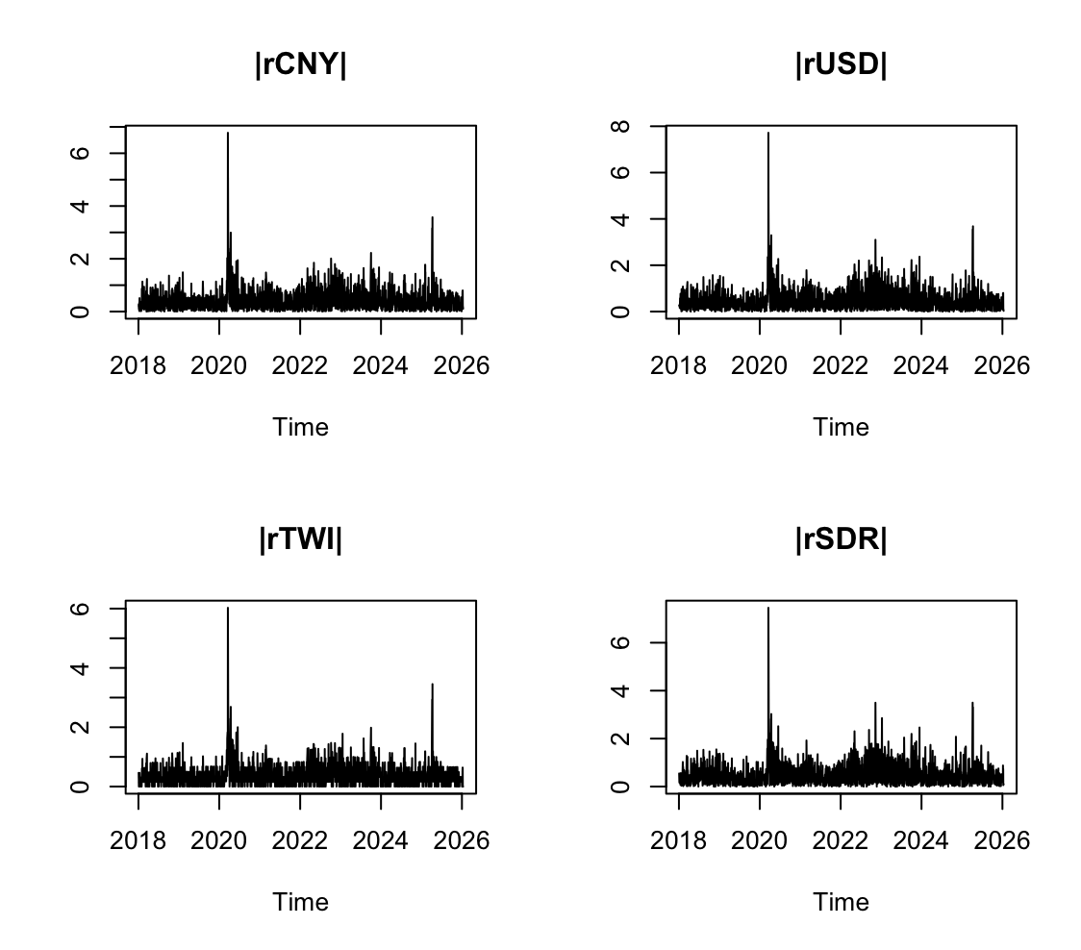
The plot of returns appears to depict an absence of iid where clear volatility clusters are observed from 2018 to 2019 and 2021 to 2024. This persistence shows that large shocks are followed by large shocks and vice versa with small shocks. This is inconsistent with a process that is iid and constant variance but instead suggests potential heteroskedasticity which meant that the exchange rates too is also heteroskedastic.
Q6

